# Robustness Diagram for Use Cases

## Robustness diagram for Become new customer [OOAD1]



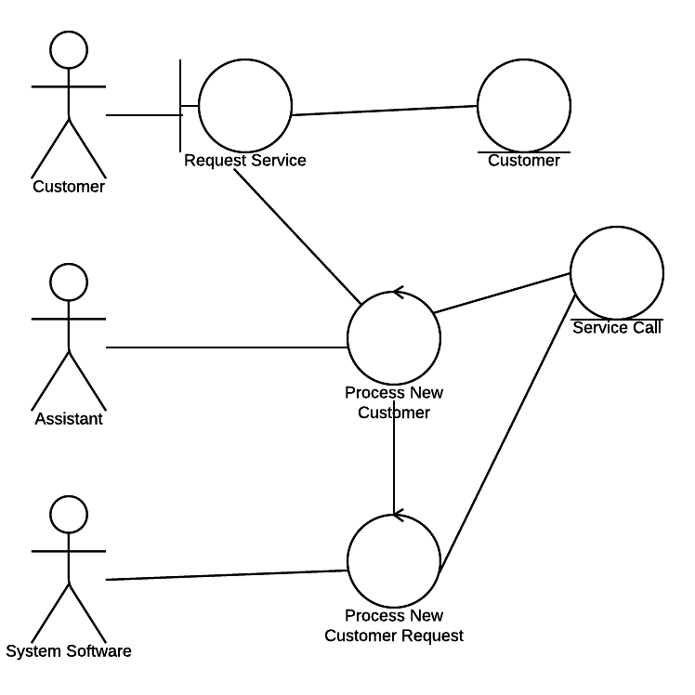

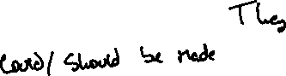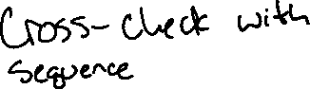

## Robustness diagram for Check\Assign Job [OOAD2]



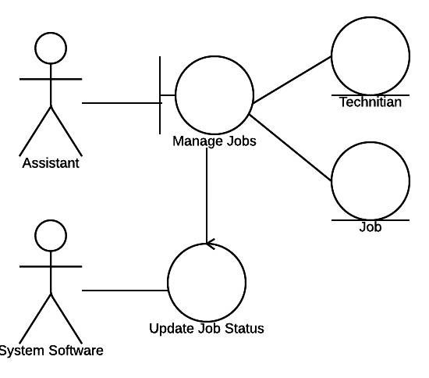

# Sequence and Collaboration Diagrams for Use Cases



## Sequence diagram for Become new customer [OOAD1]

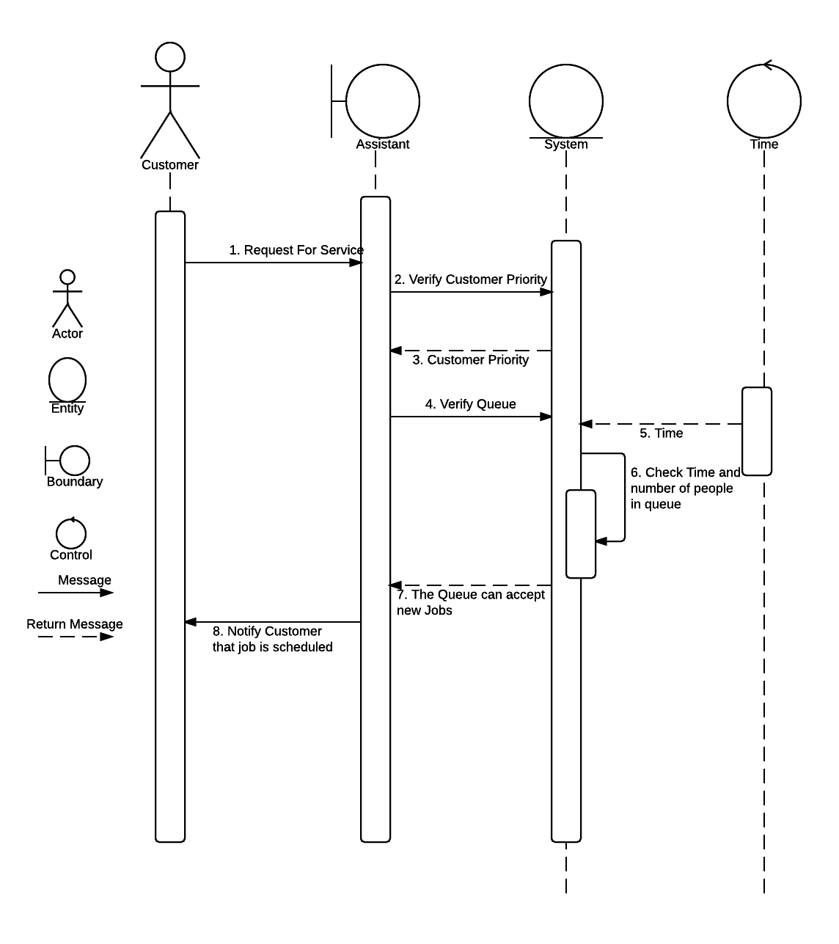



## Sequence diagram for Check\Assign Job [OOAD2]

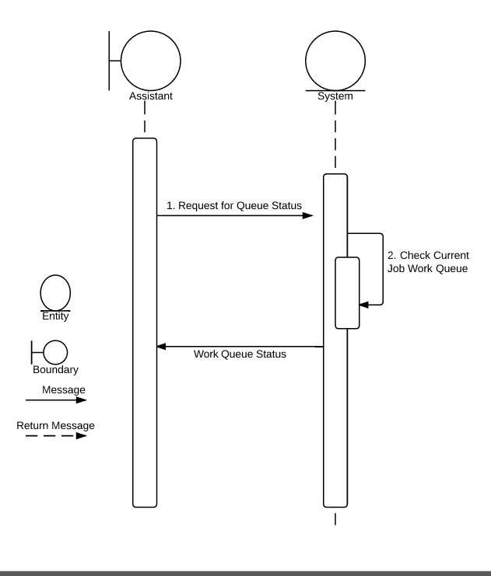

# Swimlane (Activity) Diagram for Use Cases

## Swimlane Diagram for Become new customer [OOAD1]

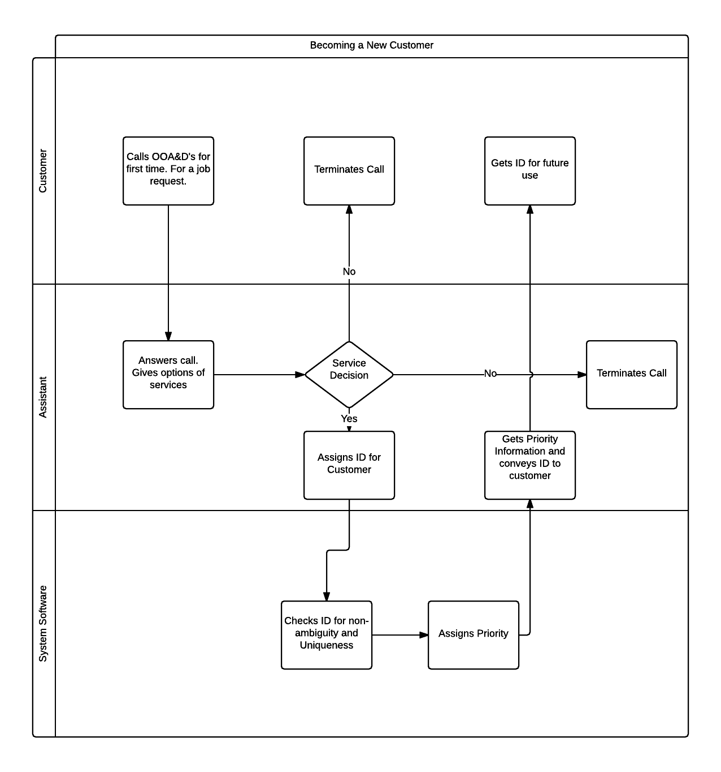

## Swimlane Diagram for Check\Assign Job [OOAD2]

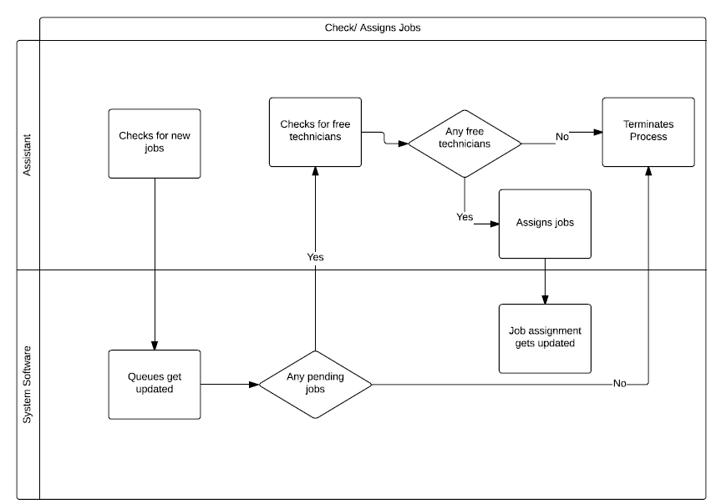

# State chart Diagram

